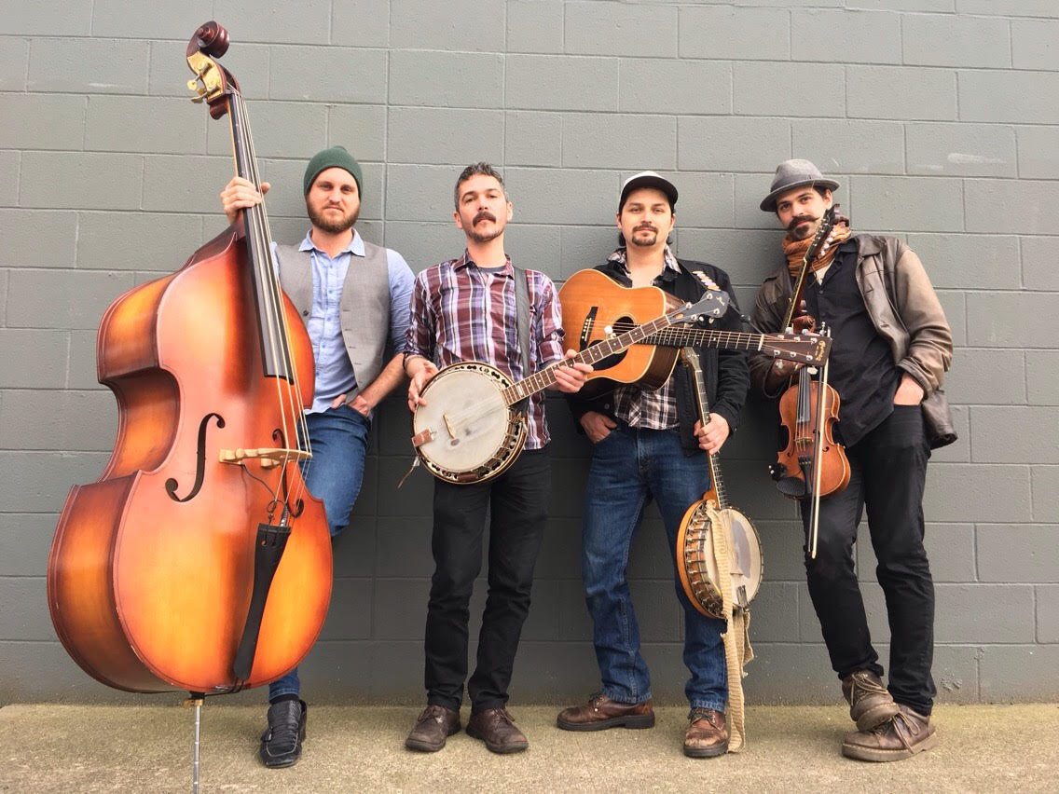

The Scratchdog Stringband is creating a name for themselves as the vanguard of a high-energy, innovative brand of bluegrass that satisfies both old-school traditionalists of the genre while enchanting modern audiences with a style of music they didn't yet know they loved. Some of the hardest working young musicians in the Pacific Northwest, the Portland-based ensemble has blazed through over three-hundred shows in the last two years alone, entertaining audiences with their rich harmonies, lush fiddle lines and break-neck banjo picking. But the Scratchdogs aren't ever married to their instruments, seamlessly passing around the upright bass, guitar, fiddle, mandolin and banjos while trading lead vocals. Their live shows feature lightning-fast rippers sung of murder and ruin, swaggering tongue-in-cheek country tunes as well as heartbreaking ballads of love and loss. Each member sings lead to their original compositions and though with voices highly unique to each other, the quartet manages to expertly blend them into resonant four-part harmonies.
______________________________________________________________________

"Scratchdog Stringband has always been consistently high quality in terms of music, people, professionalism, overall vibe, and respect."
-Lewi Longmire, booking at Laurelthirst Public House, Portland, OR

​"Scratchdog Stringband evokes the heart-and-soul of legendary stringbands. Dedicated to the craft, contemporary cool but with an incisive rearview mirror, these three top it off with fantastic vocal prowess that sets listeners back on their heels. I have been watching and waiting years for the next smokin' hot acoustic string ensemble to emerge... and Scratchdog Stringband is it!" - Lisa Lepine ProMotion Queen, creative consultant​, Portland, OR
______________________________________________________________________________

CONTACT:

Booking: James Rossi – 503.380.8895

ScratchdogStringband@gmail.com

WEB:

ScratchdogStringband.com

Facebook.com/ScratchdogStringband

Instagram.com/ScratchdogStringband

SCRATCHDOGS:
Andrew DeRossett: Guitar/Banjo/Bass
Max Skewes: Banjo/Mandolin/Bass
James Rossi: Fiddle/Guitar/Mandolin
Stephen Eggers: Guitar/Bass
DIGITAL RELEASE:
Amazon, iTunes, Spotify, CD Baby

TRACKS “Scratchdog Saloon”:
1. Left to My Own Devices
2. Tangled Laces
3. Blues Ain’t a Bad Thing
4. Wheel’s Gotta Roll
5. Blue Eyes of Rosalie
6. I Don’t Give a Damn
7. Two States
8. Other Side
9. New Hit Sound
10. Bluegrass Music

